Activity 01  | P1 | P2 | P3 | P4 | P5

# 

# **Activity 01:**

**Sequence**

**Explore Sequence using Arithmetic Operations and Assignment Statements**

**Sequence** is the default control structure for instructions or steps that are executed one after another. They might, for example, carry out a series of arithmetic operations, assigning results to variables, to find the solutions to formulas and problems.

**Sequencing** is the specific order in which instructions are performed in an algorithm.

The included projects in Activity 1 will require you to use a **sequence of steps**.

**Note :** *Conversion of* ***Floats***

*Formatting of* ***Floats*** (decimals) will be required in some questions:

[Option 1](https://stackoverflow.com/questions/455612/limiting-floats-to-two-decimal-points) | [Option 2](https://www.python-course.eu/python3_formatted_output.php)

Use your school **OneDrive** to create a folder for your Digital Solutions work.  
Naming Convention required = **DS_Surname_FirstName_ID**

**Eg DS_Mathews_Mike_0123456**

This folder will be shared with the teacher for the term

Save this file to that Folder as **“Activity01.docx”**

Note: you will also save the python files (x5)

eg **Act01_proj1**.py (Act01_proj2….…proj5)

Activity 01  | P1 | P2 | P3 | P4 | P5

# **Project 1**

Write a new Python program that prompts the user for three numbers,   
and then gives the sum and product of those three numbers.

|  |
| --- |
| Please enter 3 Numbers as prompted by program  Enter your first number : 10  Enter your second number : 2  Enter your third number : 4  The sum of these numbers is: 16  The product of these three numbers is: 80 |

Sample **output**should look like this:

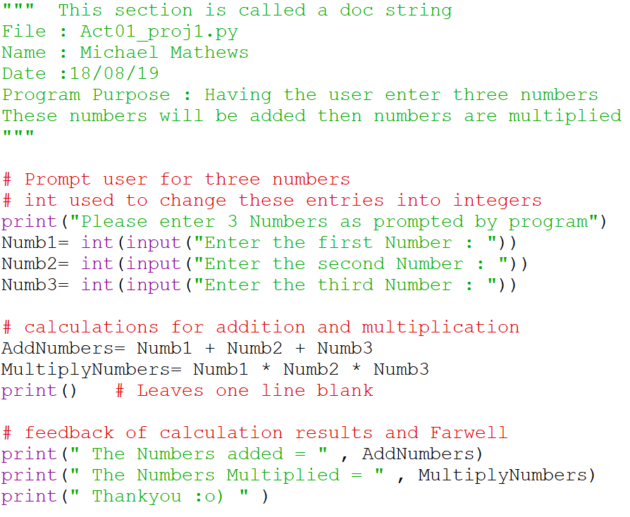

Activity 01  | P1 | P2 | P3 | P4 | P5

# **Project 2**

Write a Python program that prompts the user for their first and last name. Assuming that the user’s first name is "Monty" and their last name is "Python" and age is 16

Output using **print** a welcome message using the full name:

|  |
| --- |
| Enter your first name : Monty  Enter your last name : Python  Enter your age : 16  Digital Solutions welcomes 16 year old Monty Python |

Sample **output**

should look like this:

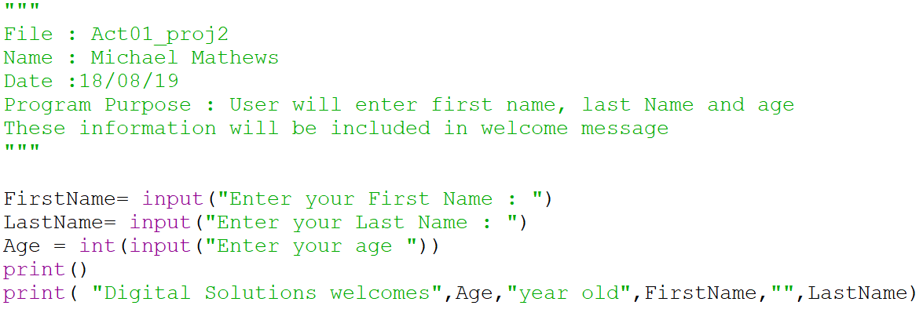

Activity 01  | P1 | P2 | P3 | P4 | P5

# **Project 3**

|  |
| --- |
| Enter your first name : Sean  Enter your surname : Bale  Enter your suburb : Robina  Enter your age : 40  **Sean** Bale from Robina will be 41 next year. |

Write a new Python program that prompts the user for their first name Surname, Suburb and Age, and then outputs the information into a sentence showing their age next year.

Sample **output**

should look like this:

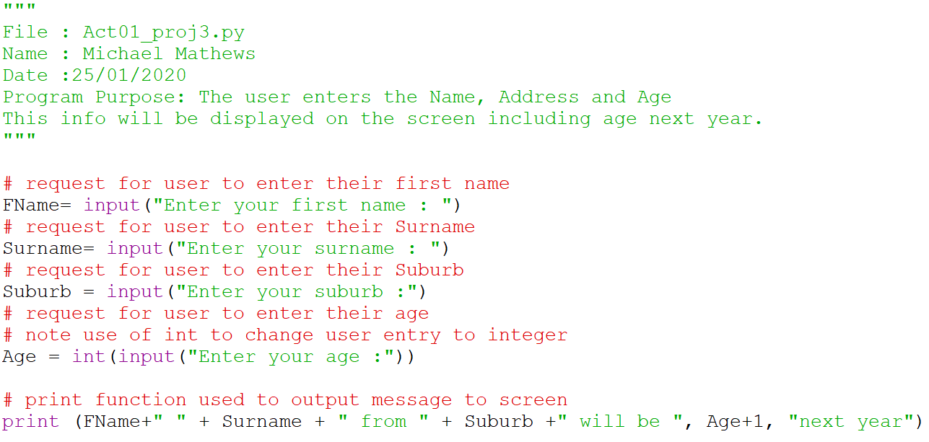

Activity 01  | P1 | P2 | P3 | P4 | P5

# **Project 4**

Write a new Python program that prompts the user for their   
**ID Number**, **Hourly Rate , and Hours worked.**

And then calculates the salary for the week ready to output to the screen with the Employee_Id and Hours worked.

Sample inputs of EmployeeID_Number: **1234** HourlyRate : $ **25** ,   
HoursWorked : **20**

|  |
| --- |
| Enter your EmployeeID_Number: **1234**  Enter your Hourly rate : $ **25**  Enter your Hours worked : **20**  This pay slip for ID No :**1234** – Hourly Rate = **$25**  Total wage for working **20** hours this week is $ **500** |

Sample **output**

should look like this:

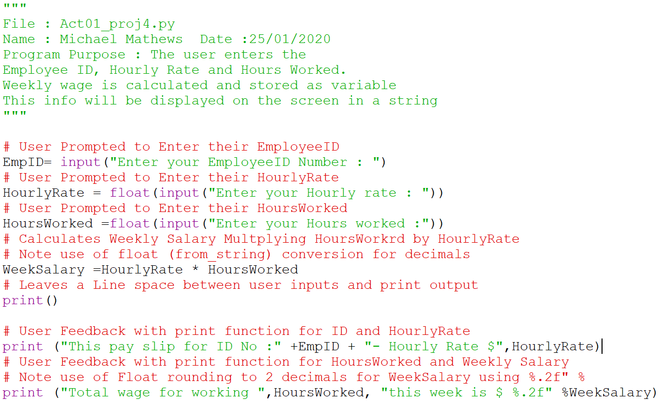

Activity 01  | P1 | P2 | P3 | P4 | P5

# **Project 5**

Use Your Code from Project 4 and **“Save As” Act01_Py_p5**

Make the adjustments to the code to include   
**Overtime** Hours Paid at **Time and Half**

Write a new Python program that prompts the user for:  
ID Number, Hourly Rate, Normal Hours **& Overtime Hours worked.**

Calculate the **weekly salary** and Output details to the screen.

print output to include : Employee_Id and Hours worked plus Overtime Hours along with the WeeklySalary,

|  |
| --- |
| Enter your EmployeeID_Number: **1234**  Enter your Hourly rate : $ **25**  Enter your normal Hours worked : **20**  Enter your Overtime Hours worked : **3**  This pay slip for ID No : 1234 - Hourly Rate $ 25.0  Total wage for working 20 hours this week is $ 590.00  This includes 3.0 hrs Overtime payment of $ 90.00 |

Sample **output**

should look like this:

